DATABASE MANAGEMENT SYSTEM ASSIGNMENT

**Name: PRIYA GUPTA**

**College roll no.: 2019/1430**

**Semester: 4th**

**CREATING AND USING DATABASE**

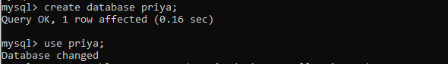

**CREATING DEPARTMENT SCHEMA**



**DESCRIPTION OF DEPARTMENT SCHEMA**

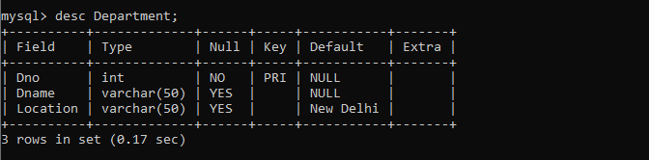

**INSERT DATA IN DEPARTMENT TABLE**

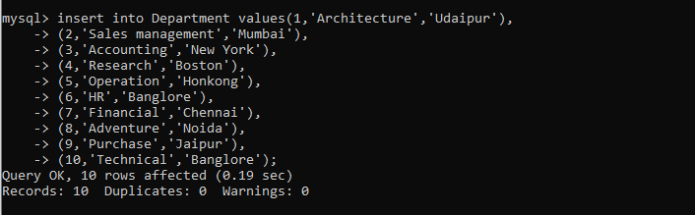

**DEPATMENT TABLE**

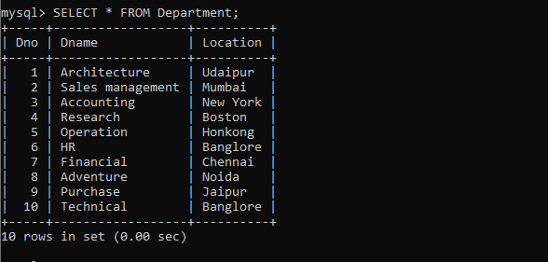

**CREATING EMPLOYEE SCHEMA**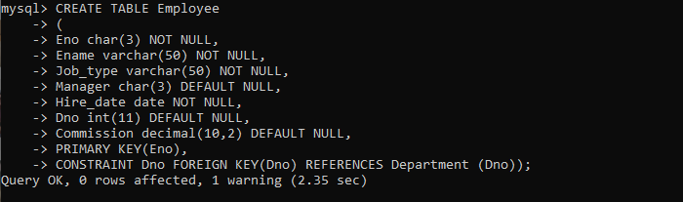

**DESCRIPTION OF EMPLOYEE SCHEMA**

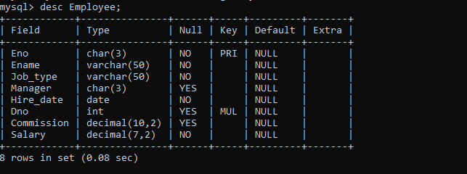

**INSERT DATA IN EMPLOYEE TABLE**

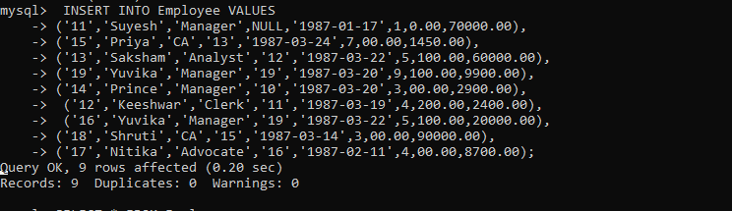

**EMPLOYEE TABLE**

